**Learning Spark**

Lightning-Fast Data Analytics

CHAPTER 1

Introduction to Apache Spark: A Unified Analytics Engine

This chapter lays out the origins of Apache Spark and its underlying philosophy.

Big Data and Distributed Computing at Google

* Seraching new way to manage Google’s search engine to index and search the world’s data on the internet (traditionnal RDBM’s wasn’t appropriate) : Creation of Google File System + Big table + MapReduce
  + Google File System provided a fault tolerant and distriuted filesystem across many commodity hardware servers in a cluster farm
  + BigTable offered Scalable Storage of structured data across GFS
  + MR introduced a new prallel programming paradigm, base on functionnal programming, for large scale processing of data distributed over GFS and BigTable

The workers in the cluster aggregate and reduce the intermediate computations and produce a final appended output from the reduce function

Sends computation code (map and reduce functions) to where the data resides,

Sends

Output written in distributive storage reachaable by the application

MAP Reduce System

Hadoop at Yahoo!

Solution for computation challenges at yahoo was express by GFS and provided the blue print for the Hadoop File System (HDFS) including Map Reduce as frameword for distributed computing => Donated to Apache software foundation in April 2006

Became Apache Hadoop with these modules :

* Hadoop Common,
* MapReduce,
* HDFS,
* Apache Hadoop YARN

Map Reduce has some inconvenient :

* Hard to manage and administer caused of cumbersonne operational complexity
* Generated batch processing, was verbose and lot of boilerplate setup code with britle fault tolerance
* MR operaton was written to the local disk for the subsequent stage and impact disk performance and duration

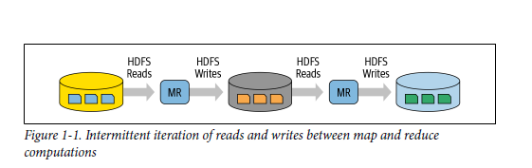

* Didn’ t work well wth someother workload as machine learning, streaming , SQL like queries (time consuming)

Some alternative, bespoke system (sur mesurre) was prosposed as Apache Hive, Apache Storm, Apache Impala, Apache Giraph, Apache Drill, Apache Mahout, etc.), each with their own APUs and cluster configurations, further adding to the operational complexity of Hafoop

Spark’s Early Years at AMPLab

Research at UC Berkeley took the challenge to male hadoop and MR simpler ad faster called it SPARK in 2009 in RAD Lab

They acknowledged that MR was inefficient (or intractable) for interactive or iterative computing jobs and a complex framework to learn.

Spark today bring the idea borrowed from Hadoop MR but enhance the system:

* Make it highly fault tolerant
* Embarrassingly parallel
* Support in memory storage for intermediate results betwee iteractive and interactive map reduce computations
* Offer easy and composable api in multiple programming languages
* Was open source in may 2014 under apache software fundation

What Is Apache Spark?

**Apache Spark** is a unified engine designed for large scale distributed data processing on premises in data centers or in the cloud

Spark provide :

* In memory storage for intermediate computation (more faster than MR)
* It incorporates libraries with composable API for machine learning (MLlib, SQL for interactive queries(spark SQL), Stream processing (Structured streaming) for interacting with real time data , Graph processing (GraphX)

Spark’s design philosophy center around four key characteristics :

* Speed
* Ease of use
* Modularity
* Extensibility

Speed

Spark gas pursied the goal of speed in several ways :

* Internal implementation (benefits from hardware imprioving in price and performance of CPU and memory)
  + Framework optimized to take advantage of efficient multitreading and parallel processing og unix-based operating system
* Spark builds its query computation as directed acylic graph (DAG), it Scheduler and query optimize construct efficient computational graph, which can be decompose into task executable in parallel across the worker
* Physical execution engine, Tungsten, uses whole stage code generatio to gnenerate compact code for execution
* With Inmemory computation / intermediate results retained in memory, it limit disk I/O give huge performance boost

Ease of Use

Spark achieves simplicity by providing a fundamental absctraction of a simple logical data strucutre called a Resilient Distributed Dataset (RDD) upon which high levl sutructured data abastractopn, such dataframe, dataset are constructed.  
By provigin set of transformation and actions we got a simple programming model that you can use to build big data application

Modularity

* Spark can be use for many workload
* Supported many programming language(Scala, python, R, SQL, Java)
* Unified labraries, with API with the following modules as core components:
  + Spark sql
  + Spark structured programming
  + Spark MLIB
  + GraphX
* A unified processing engine which run all these librairies

Extensibility

* Spark need to read and write data on a storage, it can sotre on Hadoop, Cassandra, HBase, MongoDB, Hibe, RDBMS…
* Spark community maintains a list of third party spark packages including spark connector for variety of external sources

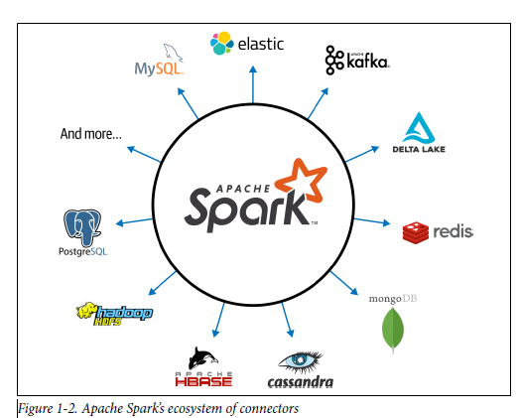

Unified Analytics

“Unified Engine for Big Data Processing.” The award-winning paper notes that Spark replaces all the separate batch processing, graph, stream, and query engines like Storm, Impala, Dremel, Pregel, etc

Apache Spark Components as a Unified Stack

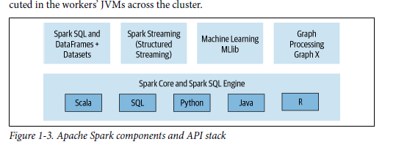

* Spark offers 4 distinct libraires for diverse workloads:
  + Spark SQL:
    - Work well with structured data
    - You can read from RDBMSs, file format with structured data (CSV, text, json, avro, orc, parquet) =>(construct) permanent or temporary tables in spark
    - Spark is ANSI SQL: 2003 compliant
    - Can combine spark structured streaming and spark sql

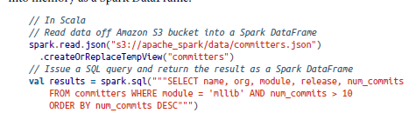

* + Spark MLlib
    - Spark contains librairies with common machine learning algorithms
    - Machine learning algorithms are built atop highlevel dataframe api
    - API alow
      * Extract or transform feature
      * Build piplines(for training and evaluating)
      * Persit models (for saving and reloading them)
      * MLlib includes other low-level ML primitives, including a generic gradient descent optimization.

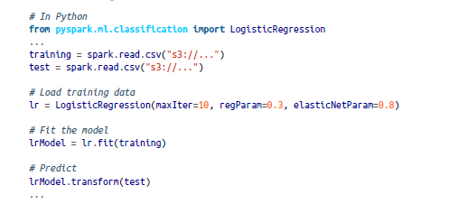

* + Spark structured Streaming
    - Apache spark 2 introduce an experimental continuous streaming model and structured streaming APIs
    - Available by Spark 2.2
    - Necessary to combine and react in real time to both static data as streaming data from engines like Apache Kafka
    - View stream as a continually growing table with new row appended at the end
    - Developers can merely treat this as a structured table and issue queries against as it is a static table
    - Spark Sql core engine handles all aspect of fault tolerance and late data semantics (more easier for developer)
    - It replace Dstreams data structure
    - It read from a localhost socket, apache kafka, kinesis and HDFS based/cloud

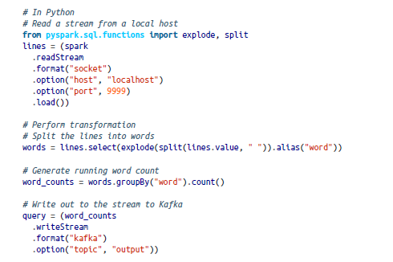

* + GraphX
    - Librairies manipulation graph and perfoming graph parallel computations
    - Standard graph algorithms for analysis, connections and traversals (PageRank, Connected Components, triangle counting..)

Each of these libraries are separate from spark’s core fault tolerant engine :

use APIs(Spark SQL, graphX, MLlib, java ..) =>(spark application convert to) DAG =>(DAG execute by) Core engine

Apache Spark’s Distributed Execution

Spark is a distributed data processing engine with its components working collaboratively on a cluster of machine

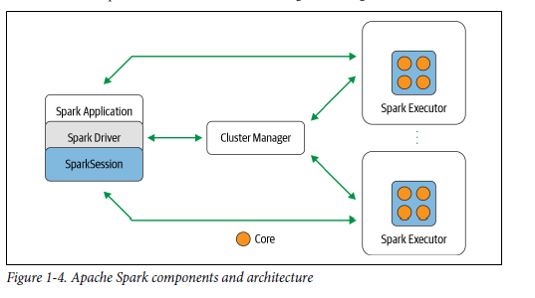

(Art high level) Driver program (orchestrating parallel operatons)=> (access) distributed components in the cluster (spark executors and cluster manager through sparksession)

* Spark Driver
  + Instantiating a sparksession ,
  + Communicate with the cluster manager and request resources (CPU, memory etc..)
    - From the cluster manager for spark’s executor (JVM)
  + Transforms all the spark operations into DAG computations, schedules them and distributes their execution as tasks across spark exectuors
  + Once resources are allocated, it commincates directly with the executors
* SparkSession
  + In Spark 2.0 sparksession became a unfied conduit to all spark operations and data (not only subsume previous entry point to spark sparkcontext, sqlcontext, hivecontext, sparkconf and streamingContext but also made working wih spark simpler and easier
  + From this sparksession tou can
    - Create JVM runtime parameter
    - Define dataframes and datasets
    - Read from data sources
    - Access catalog metadata
    - Issue spark sql queries …
  + Can create it using high level api in any languages available
  + It is created autmaticaly when running spark shell and access through spark , sc

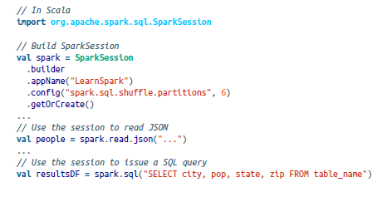

* Cluster manager
  + Responsible for managing and allocating resources for the cluster of node on which your spark application runs (see code sources)
  + Spark support 4 cluster managers:
    - Standalone cluster manager
    - Apache Hadoop YARN
    - Apache Mesos
    - Kubernetes
* Spark Executor
  + A spark executor runs on each worker node in the cluster
  + Communicationg with the dirver program and responsible for executing tasks on the workers in most deplouments modes, only a single executor runs per node
* Deployment modes

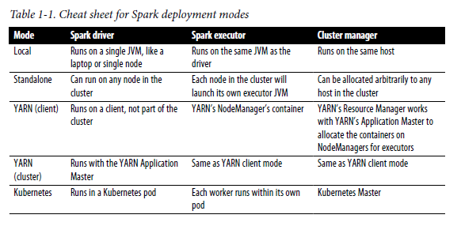

* Distrbuted data and partitions
  + Data is distributed ad partitions across the physical cluster
  + Spark treats each partition as a high level logical data abstraction as DataFrame in memory
  + Each spark executor is preferably allocated a task that requires it to read partition closest to it in network , observing data locality
  + Partitions allow for efficient parallelism

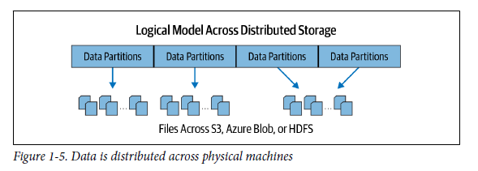

* A distributed scheme of breaking up data into chunks or partitions allows Spark executors to process only data that is close to them, minimizing network bandwidth.

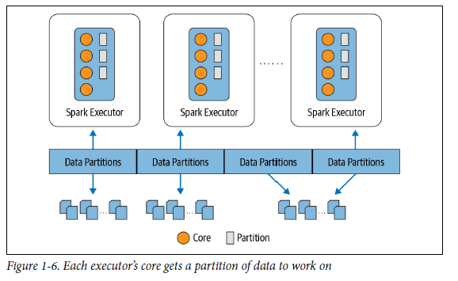

The Developer’s Experience

Apache spark was adopt because of :

* Its easy to use API for operationg on small to large data sets acess language Scala Java Python SQL and R

Who Uses Spark, and for What?

* Developer who grapple with big data ( data engineers, data scientist or machine leanring engineers)
* Allow to build a range of applications using a single engine, familiar with their programming languages

Data science tasks

* Cleanse data , explore it to discover patterns and builfs models to predict or suggest outcomes
* Their use SQL , Numpy, pandas, R and python
* Spark MLlib offers a common set of machine learning algorithms to build pipelines, Spark SQL and Spark shell facilitae interactive and ad hoc exploration of data
* Spark 2.4 introduced a new gang scheduler, as part of project Hydrogen to accommodate the fault tolerant need of training and Spark 3 introduce the ability to support GPU resource collection (for deep learning)

Data engineering tasks

* Deploying model
* Build and transform raw, dirty data into clean data that is easly consumable or usable by other data scientist
* Build large pipeline for with streaming engine / with web application
* Performance improvement on Spark 2.x and 3.0 due to Catalsyt optimizer (for SQL and Tungsten (for compact code généretation

Popular Spark use cases

* Whether you are a data engineer, data scientist, or machine learning engineer, you’ll
* find Spark useful for the following use cases:
* Processing in parallel large data sets distributed across a cluster
* Performing ad hoc or interactive queries to explore and visualize data sets
* Building, training, and evaluating machine learning models using MLlib
* Implementing end-to-end data pipelines from myriad streams of data
* Analyzing graph data sets and social networks
* Spark 1.0 first released 2014

CHAPTER 2

Downloading Apache Spark

and Getting Started

* In local mode running, procession is donne on a single machine, spark shell which providing quick feedback loop for iteratively performing spark operations
* Spark shell help to prototype spark operation with small dara sets before writing a complex spark application
* Spark shell only supports scala , python,and R

Step 1: Downloading Apache Spark

* Since Spark 2.2, when we want only use Pyspark we can install through PyPI repository
* Some extra dependencies can be created pip install pyspark[sql,ml,mllib] (or pip install pyspark[sql] if you only want the SQL dependencies).

Spark’s Directories and Files

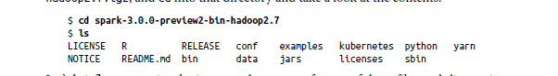

* Bin
  + Contains most of the scipts employ to interact with spark (spark-shell, spark sql, pyspark, sparkR)
  + Can submit standalone application using spark-submit
  + Scripts to builds and pushes docker images when running spark with kubernetes support
* Sbin
  + Script with administrative purpose for starting and stopping spark components in the cluster in its various deployment modes
* Kubernetes
  + Contains dockerfiles for creating docker images for spark on a kubernetes cluster
  + Contains fole providing instructions on how to build the spark distribution before building your docker images
* Data
  + Directory populated with *.txt files that serve as input for spark’s components: MLlib, structured streaming, and GraphX
* Examples

Step 2: Using the Scala or PySpark Shell

* Spark comes with four widely used interpreters that act like interactive shells and enable ad hoc data analysis: pyspark, spark-shell, spark-sql and sparkR
* Shell has benn augmented to support connecting in the cluster and to allow you to load distributed data into spark wokers memory

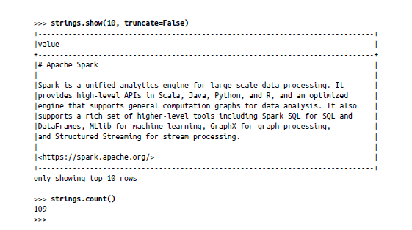

Every computation expressed in high-level Structured APIs is

decomposed into low-level optimized and generated RDD operations and then converted into Scala bytecode for the executors’ JVMs. This generated RDD operation code is not accessible to users, nor is it the same as the user-facing RDD APIs.

Step 3: Understanding Spark Application Concepts

How spark transformed code and executed as tasks across the spark executors

* Application
  + A user program built on spark using its APIs. Its consists of a driver program and executor on the cluster
* SparkSession
  + An object that provides a point of entry to interact with underlying spark functionality and allows programming spark with its APIs. In an interactive spark shell, the spark driver instantiates a SparkSession
* Job
  + A parallel computation consisting of multiple tasks that gets spawned in response to a spark action (save(), collect())
* Stage
  + Each job gets divied into smaller sets of tasks called stages that depend on each other.
* Task
  + A single unit of work or execution that will be sent to a spark executor

Spark Application and SparkSession

* Spark driver program is at the core of every spark application
* Spark driver created => sparkSession object

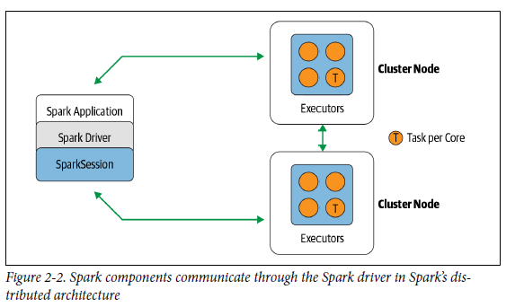

* Once you have a SparkSession, you can program spark using the APIs to perform spark operations

Spark Jobs

* During interactive sessions with spark shells, the driver convert spark application into one or more spark jobs
* Jobs It then => transforms each job into DAG (essence of spark execution plan)
* Each node within a DAG could be a single or multiple spark stages

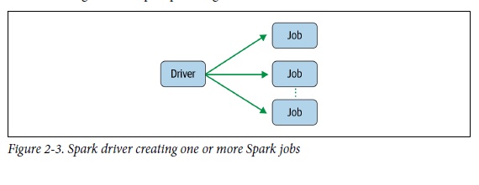

Spark Stages

* Stage are created based on what operations can be perfomed serially or in parallel (not all spark operations can happen in a single stage)
* Spark stages delineated on the operator’s computation boundaries, where they data transfer among spark executors ( shuffle)

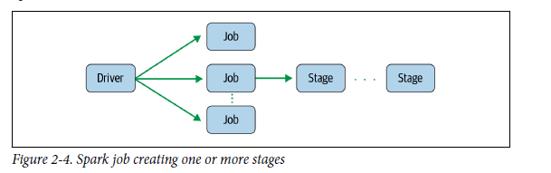

Spark Tasks

* Stage comprised of spark tasks (a unit of execution), federated across each spark executor
* Each task maps to a single core and works on a single partition of data
* with 16 cores can have 16 or more tasks working on 16 or more partitions in parallel, making the execution of Spark’s tasks exceedingly parallel!

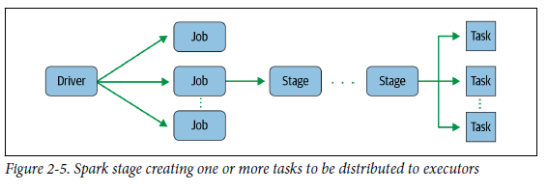

Transformations, Actions, and Lazy Evaluation

* Spark Operations is classified into two types : transformations and actions
* Transformations
  + Transform spark dataframe into new dataframe without altering the original data it the prooerty of immitability
  + Transformations will not change the original dataframe , instead it will retrun the transformed results of the operation as new dataframe
  + All transformation are evaluated lazily (their results are not computed immediately, but they are recorded or remembered as a lineage )
  + Recorded lineage allowd spark to rearrange certain transformations coalesce them or optimize transformation into stage for more efficient execution
  + Lazy evaluation is Spark’s strategy for delaying until an action is invoked or data touched (read or write

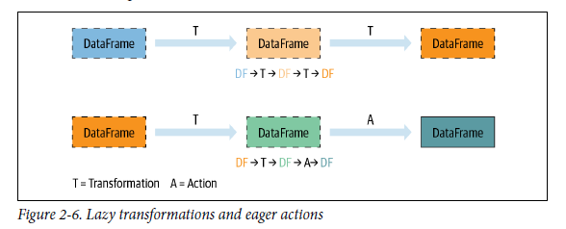

* Lazy evaluation allows spark to optimize your queries by peeking into your chained transformations, lineage and data immutability provide fault tolerance
* Spark record each transformation in its lineage and the DataFrames are immutable between transformations, it can reproduce its original state by simply replaying the recorded lineage giving resiliency

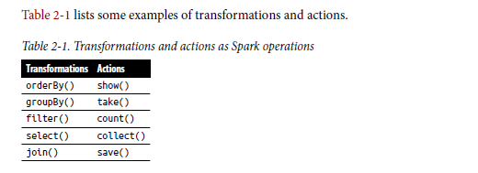

* The actions and transformations contribute to a spark query plan
* The actions triggers the execution of all transformations recorded as part of the query execution

Narrow and Wide Transformations

* Spark transformatons are operations that spark evaluates lazily
* Avatange of lazy evaluation scheme is that spark can inspect the computational query and ascertain how it can optimizer it
* Optimization can be done by joining or pipelining some operations and assigning them to a stage
* Operations is break into Stages by determining which operation require shuffle or exchange of data across clusters
* Transformation can be classify
  + Narrow dependencies: transformation where a single output partition can be computed from a single input partition   
    ex: filter() & contains() are narrow because they can operate on a single partition and produce the resulting output partition without any exchange data
  + Wide dependencies: data from other partitions is read in, combined and written to disk, these force shuffle of data from each of the executor’s partitions across the cluster , require data from other partition for computation

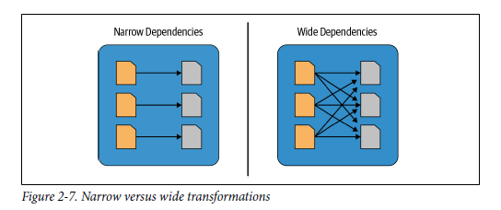

The Spark UI

* Spark include a graphical user interface, it use to
  + Inspect or monitor spark application in their various stage or decomposition (jobs, stages, tasks)
* Driver launches(depending on how spark is deployed) a web UI, running by default on port 4040
  + A list of scheduler stages and tasks
  + A summary of RDD size and memory usage
  + Informations about the environment
  + Informations about the running executors
  + All the spark SQL queries
  + Can be access in local through *http://<localhost>:4040*

When you launch spark-shell, part of the output shows the localhost

URL to access at port 4040

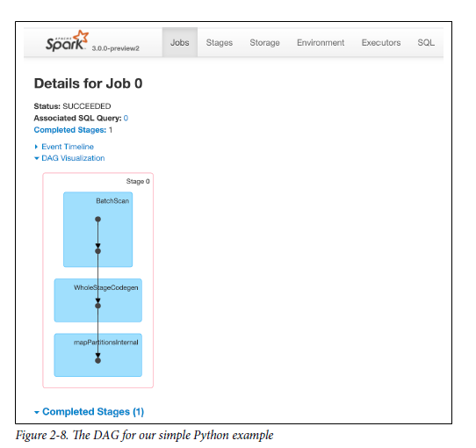

* mapPartitionInternal for internal moving of data

Your First Standalone Application

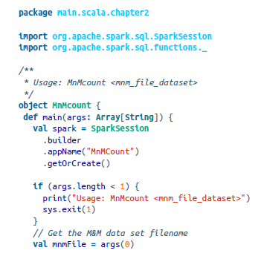

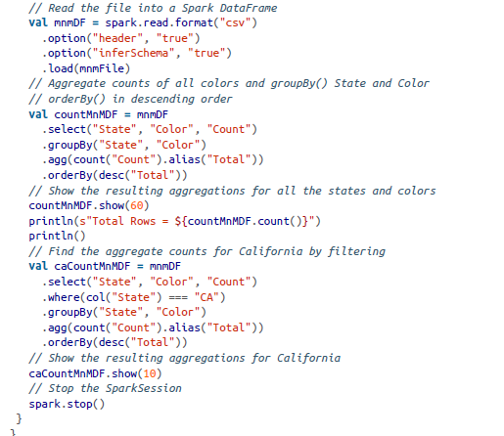

Building Standalone Applications in Scala

Because Python is an interpreted language and there is no such

step as compiling first (though it’s possible to compile your Python

code into bytecode in .pyc), we will not go into this step here. For

details on how to use Maven to build Java Spark programs, we refer

you to the guide on the Apache Spark website. For brevity in this

book, we cover examples mainly in Python and Scala.

* build.sbt is the specification file that, loke makefile, describes and instruts the scala compler to build yout Scala related tasks (jars, packaches)

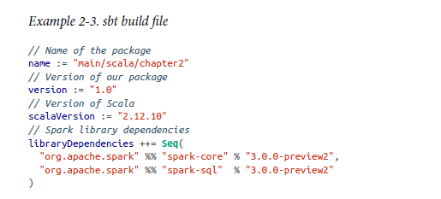

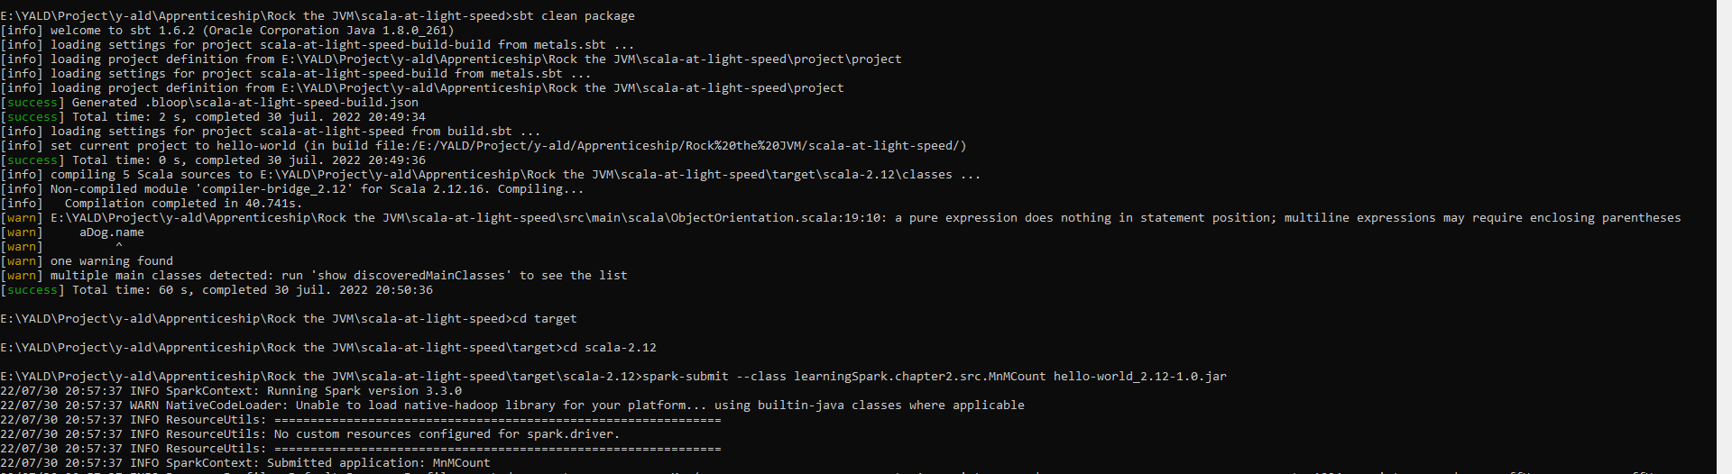

spark-submit --class learningSpark.chapter2.src.MnMCount hello-world_2.12-1.0.jar

CHAPTER 3

Apache Spark’s Structured APIs

* Dataframe was introduce in Spark 1.3 and Spark SQL in spark 1.x
* Creation of high-level APIs (DataFrame and Dataset) unification in spark 2.x

Spark: What’s Underneath an RDD?

* RDD is the most basic abstraction in spark
  + Dependencies:
    - instructs spark how an RDD is constructed with is inputs is required.
    - When necessary to reproduce results, spark can recreate an RDD from these dependencies and replicate operations on it
    - It gives RDD resiliency
  + Partitions (with some locality information)
    - Partition provide the ability to split the work to parallelize computation on partitions across executors
    - In some case (HDFS) spark will use locality information to send work to executors close to the data (data less transmited over network)
  + Compute function: partition => Iterrator[T]
    - Compute function that produces an Iterator[T] for data that will be stored in the RDD
* There is some problem with these principle
  + Compute function(computation) is opaque to spark, spark see only lambda expression
  + Iterator data type is also opaque for python RDDs, spark only knows that it is a generic object python
  + As spark is unable to inspect the computation or expression , spark has no way to optimize it
  + Spark have no information on data type of, all it can do is serialize the opaque object as a series of bytes , without data compression technique

Structuring Spark

* Spark 2.x introduced a few key schemes for structuring spark
  + Express computation by using common patters found in data analysis (these pattern are expressed as high-level operations ex: filtering …)
  + Bring clarity and simplicity
* This specificity is further narrowed through use of set of commend operators in a DSL, available as APIs in Spark’s supported language
* These operator tell spark what you wish to compute with your data, the result can construct efficient query plan for execution
* Final scheme of order and structure is to allow to arrange data in tabular format as SQL, with supported structured data types

Key Merits and Benefits

* Structure yields a number of benefits
  + Better performance and space efficiency across spark components
  + Expressivity, simplicity, composability, and uniformity
  + Ex expressivity and composability

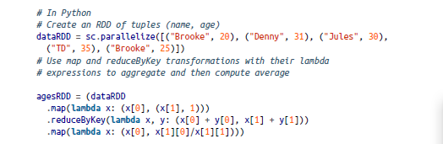

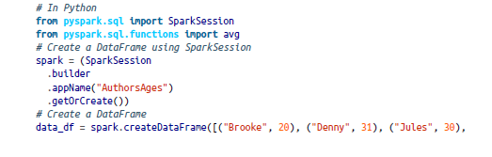

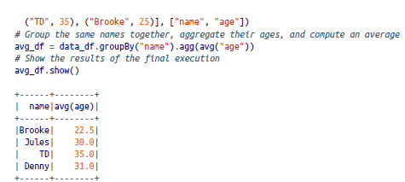

* This code is far more expressive as well as simpler than the earlier version ( because of high-level DSL operator and APIs to tell Spark what to do)
* Use Operator to compose our query and spark API allow spark to understand it
* Spark can inspect and parse these query => can optimize to arrange the operations for efficient execution
* DSL operators introduce to Order and structure by mapped to command recurring data analysis
* Limit the scope of developer to instruct the compiler or control how their queries should e computed

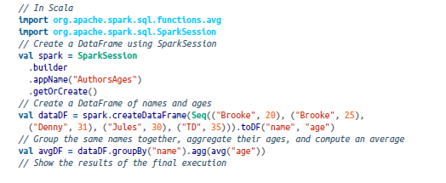

* The simplicity and expressivity allow by Spark SQL engine upon which the high-level structured APIs are builts ( perform query against dataframe in Structured streaming // or MLlib) it uniformize

The DataFrame API

* DataFrame is inspired by pandas DataFrame in structure, format and a few specific operations
* Spark dataFrame are liker distributed in memory tables with named columns and schemas , where each column has a specific data type : integer, string , array map, real date, timestamp etc
* Example of DataFRame in human eye

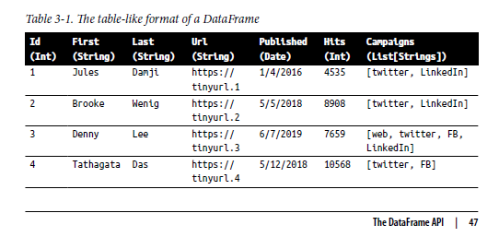

* Put data as structured table
  + Easier to digest and work with when come common operations to execute on row and columns
* DataFrame are immutable and Spark Keeps a lineage transformations
  + Can do various transformations while the previous version are preserved
* A named column in DataFrame and its associated Spark data type can be declared in te schema

Spark’s Basic Data Types

* Matching its supported programming languages, spark supports basics internal data type, which can be declared in spark application or defined in the schema

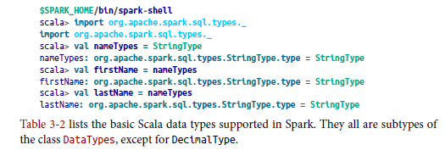

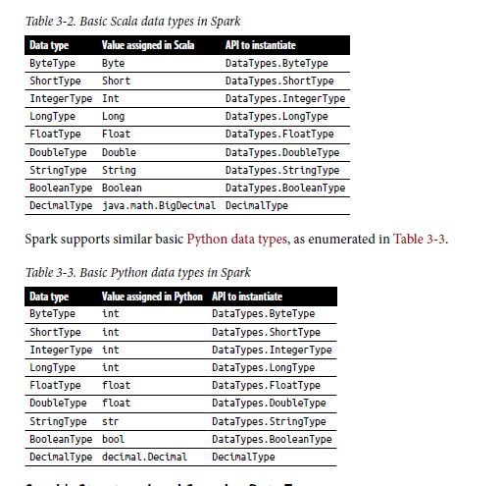

Spark’s Structured and Complex Data Types

* For complex data analytics as structured or nested we can need to handle these complex data types : maps , arrays, structs, dates , timestamps , fields

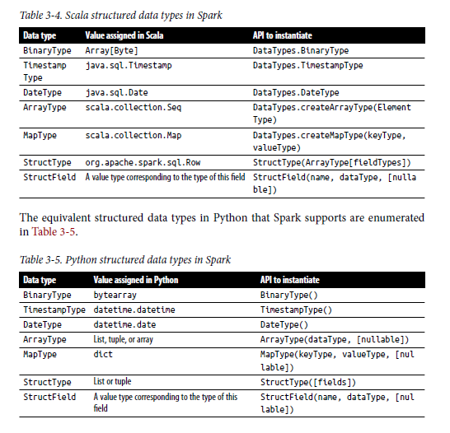

Schemas and Creating DataFrames

* A Schema in spark defines the column names and associated data types for a DataFrame.
* Most often, it use when when reading structured data from an external data source
* Defining a schema up front as opposed to taking a schema on read approach offers three benefits :
  + You relieve spark from the onus of inferring data types
  + You prevent spark from creating a separate job just to read a large portion of your file to ascertain the schema, which for a large data file can be expensive and time-consuming
  + You can delect errors early if data doesn’t match the schema
* Define schema

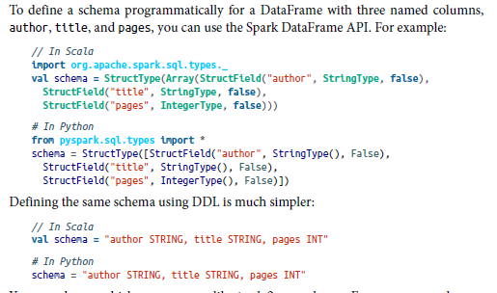

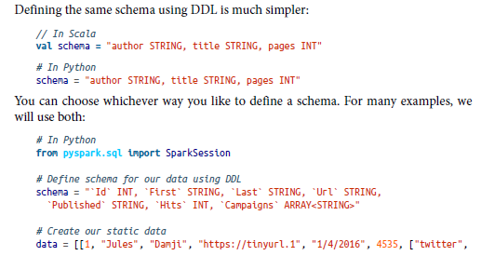

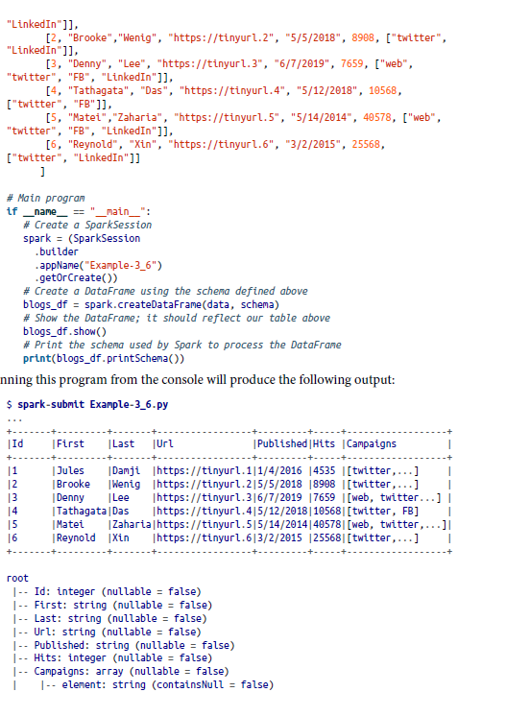

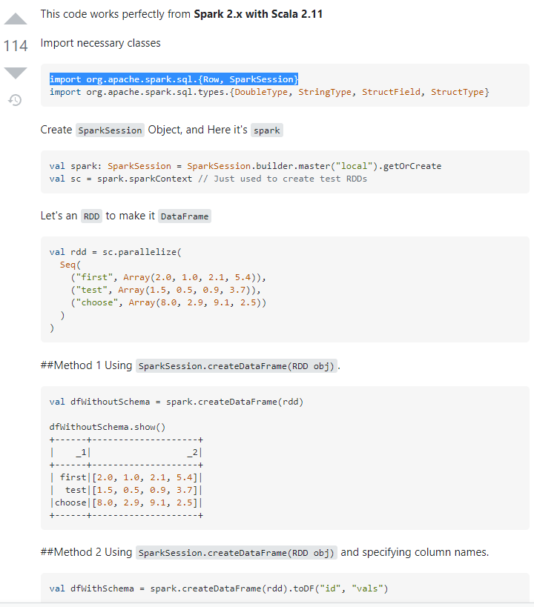

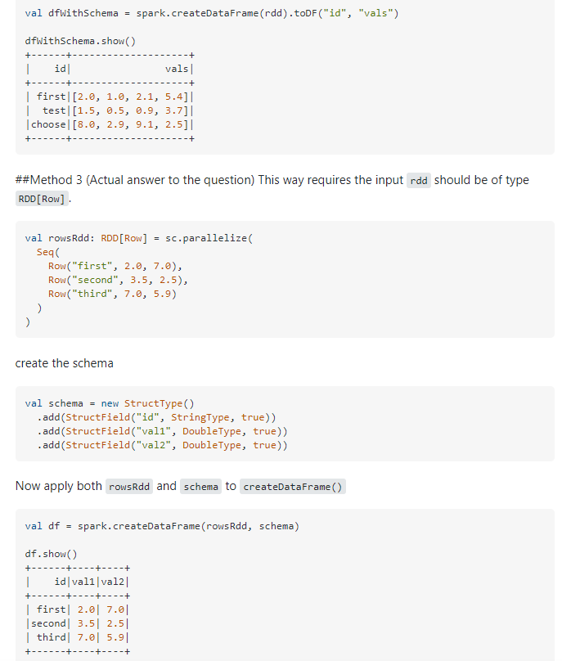



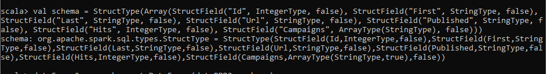

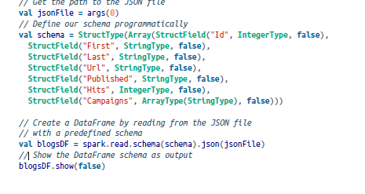

import org.apache.spark.sql.types._

import org.apache.spark.sql.Row

val schema = StructType(Array(StructField("Id", IntegerType, false), StructField("First", StringType, false), StructField("Last", StringType, false), StructField("Url", StringType, false), StructField("Published", StringType, false), StructField("Hits", IntegerType, false), StructField("Campaigns", ArrayType(StringType), false)))

val dataRDD2 = sc.parallelize(List((1, "Jules", "Damji", "https://tinyurl.1", "1/4/2016", 4535,List("twitter","LinkedIn")),(2, "Brooke","Wenig", "https://tinyurl.2", "5/5/2018", 8908, List("twitter","LinkedIn"))))

val dataFrame2 = spark.createDataFrame(dataRDD2.map(x => Row(x._1, x._2, x._3, x._4, x._5, x._6, x._7)), schema)

Columns and Expressions

* Named columns in DataFrame are conceptually similar to named columns in pandas or R DataFrames or in an RDBMS
  + They describe the a type of field
  + All column can be listed by they name
  + Operation on value of the column using relational and computational expressions
* Columns are objects with public methods (represented by column type)
* Logical and mathematical expression can be used on column EX: expr("columnName * 5") or(expr("columnName- 5")>col(anothercolumnName)),
* Expr() is part of org.apache.spark.sql.functions (Scala) packages

Scala, Java, and Python all have public methods associated with columns.

You’ll note that the Spark documentation refers to both col

and Column. Column is the name of the object, while col() is a standard

built-in function that returns a Column.

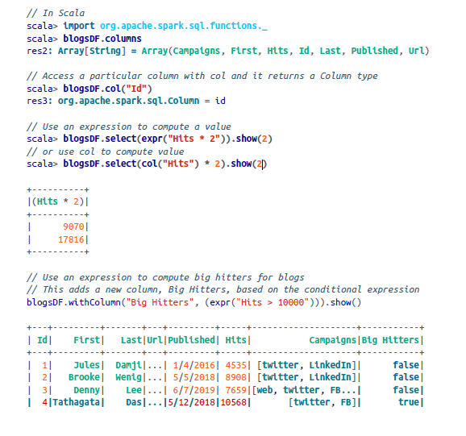

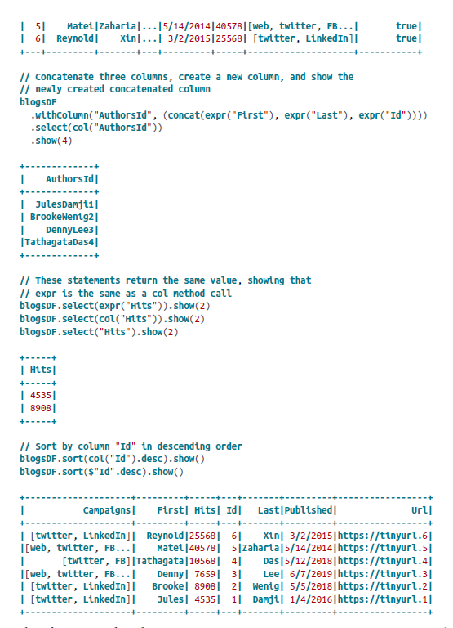

* In this last example, the expressions blogs_df.sort(col("Id").desc) and blogsDF.sort($"Id".desc) are identical. They both sort the DataFrame column named Id in descending order
  + Explicit function col(“Id”) to return a column object
  + $ convert column name into Column object

We have only scratched the surface here, and employed just a couple of methods on Column objects. For a complete list of all public methods for Column objects, we refer you to the Spark documentation.

* Column object in a DataFrame can’t exst in isolation; each column is part of a row in a record and all the rows together contitue a DataFrame

Rows

* A Row in spark is a generic Row object, containing one or more columns (same or different type)
* Row can be instantiate in each of spark’s supported language, cause is an object in spark and ordered collection of field

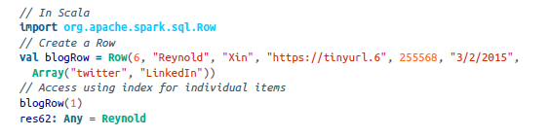

* Can be used to created dataFrame

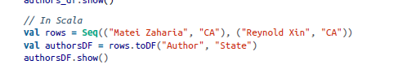

Common DataFrame Operations

* To perform common data operations on DataFrames , need to load a DataFrame from a dara source that holds your structured data
  + DataFrameReader : enable to read data to DataFrame from different data sources format JSON, CSV, parquet, Avro, ORC, Text …
  + DataFrameWritrer to write back DataFame to different data sources format

Using DataFrameReader and DataFrameWriter

* Reading and writing are simple because of hilgh level abstraction
* Data source include NoSQL sotres, RDBMS, streaming engine Apache Kafka and Kinesis

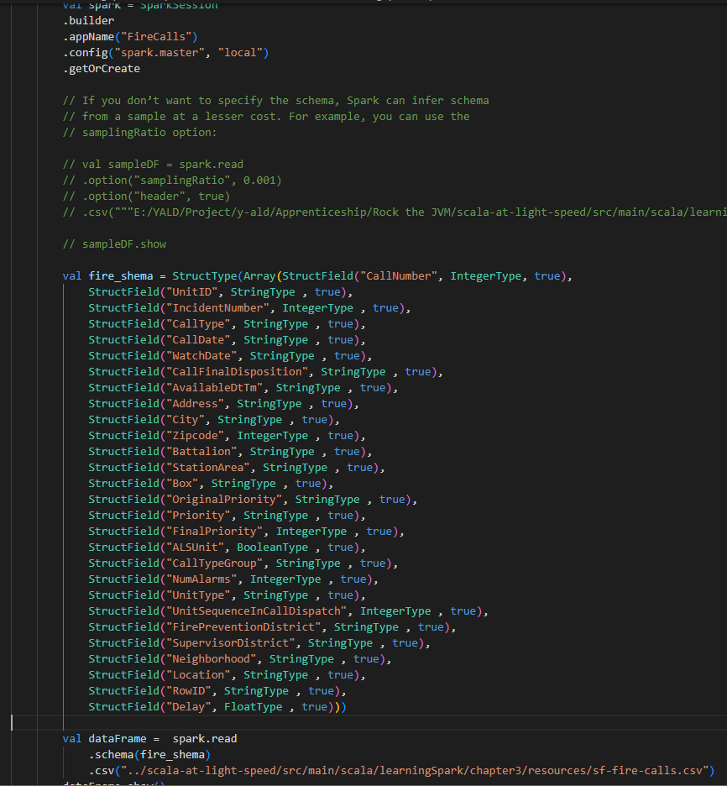

* For writing data parquet is the most popular format and it is the default one
  + When writing in parquet it keeps the schema in a metadata file, so no need to specific the schema in cas of subsequent reads
* Save as parquet or SQL table



* When save as table it registers metadata with the Hive metaStore

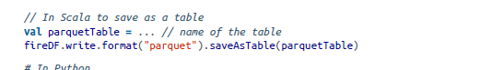

Transformations and actions

* Projections and filters.
  + Projection (in relational parlance) is a way to return only rows matching a certain relational condition by using filters
  + In spark is done with select(), filter(), where()

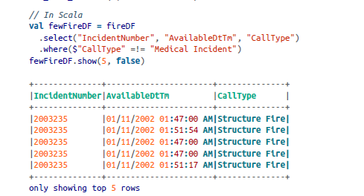

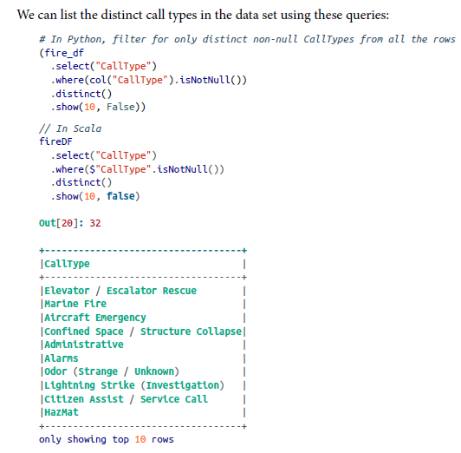

* Renaming, adding, and dropping columns.
  + Space in column can be problematic spcially when try to write in some data source (parquet)

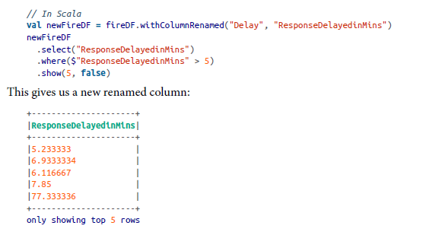

Because DataFrame transformations are immutable, when we rename a column using withColumnRenamed() we get a new DataFrame while retaining the original with the old column name.

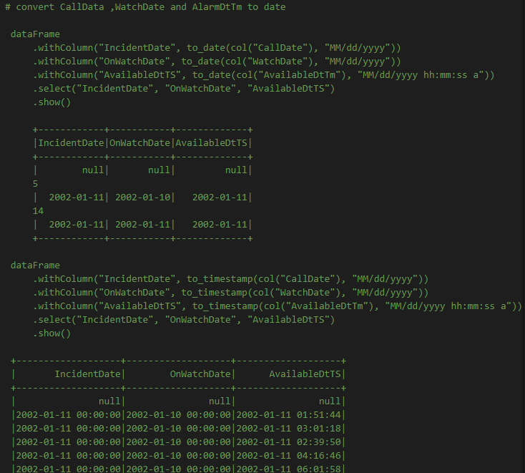

* Another transformation date , leet see what it do
  + Convert existing column’s data tume from string to spark supported timestamp
  + Use the new format specified in the format string “MM/dd/yyy” or
  + After converting to the new data , append the new column specified in the argument withColumn
  + Assign the new modified DataFrame to fire_ts_df
* Note that there is functions from spark.sql.functions like month(), year(), day() to explore date data EX:

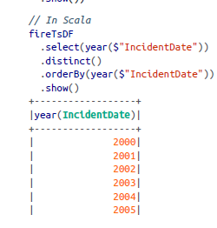

Aggregations. : The purpose of aggregation is to regroupind data by value to simplify the counting, projection, aggregation and filtering

* groupBy(), orderBy() and count() (transformation and action) offer the ability to aggregate by column names and then aggregate counts across them

For larger DataFrames on which you plan to conduct frequent or repeated queries, you could benefit from caching. We will cover DataFrame caching strategies and their benefits in later chapters.

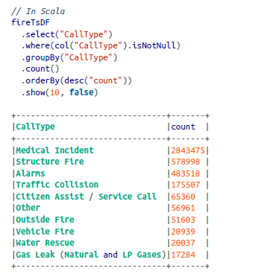

The DataFrame API also offers the collect() method, but for

extremely large DataFrames this is resource-heavy (expensive) and

dangerous, as it can cause out-of-memory (OOM) exceptions.

Unlike count(), which returns a single number to the driver, col

lect() returns a collection of all the Row objects in the entire Data‐

Frame or Dataset. If you want to take a peek at some Row records

you’re better off with take(n), which will return only the first n

Row objects of the DataFrame.

Other common DataFrame operations. :

* DataFrame also provide statistica methods like min(), max(), sum() and avg()
* Some of alarls , the average respond time and minimum maximm respone times

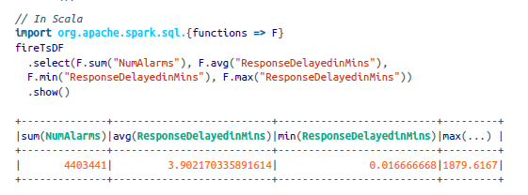

* For more advanced statistical needs there is methods like stat(), describe, correlation, covariance, sampleBy, approxQuantile, frequentItems and so on

End-to-End DataFrame Example

TODO

• What were all the different types of fire calls in 2018?

• What months within the year 2018 saw the highest number of fire calls?

• Which neighborhood in San Francisco generated the most fire calls in 2018?

• Which neighborhoods had the worst response times to fire calls in 2018?

• Which week in the year in 2018 had the most fire calls?

• Is there a correlation between neighborhood, zip code, and number of fire calls?

• How can we use Parquet files or SQL tables to store this data and read it back?

The Dataset API

* Spark 2.0 unified the DataFrame and Dataset APIs as Structured APIs with similar interfaces so that developers would only have to learn a single set of APIs
* Datasets take on two characteristic : typed and untyped APIs

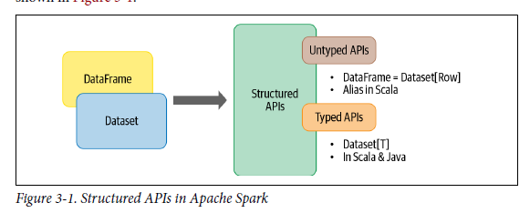

* Conceptuality DataFrame in Scala is an alias for a collection of generic object, Dataset[Row] (Row is a generic untyped JVM object that may holds different types of fields )
* Dataset is a collection of strongly typed JVM objects in Scala or a class in JAVA

a strongly typed collection of domain-specific objects that can be transformed in parallel using functional or relational operations. Each Dataset [in Scala] also has an untyped view called a DataFrame, which is a Dataset of Row.

Typed Objects, Untyped Objects, and Generic Rows

* Datasets make sense only in scala and java (cause python and R are not compile time type safe, types are dynamically inferred or assigned during execution)
  + In Scala, java types are bound to variable and object at the compile time

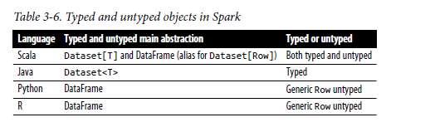

* Row is a generic object type in spark, holding a collection of mixed types thanc ca be accessed using an index.
  + Internally spark manipulates row as objects , converting them to the equivalent types covered

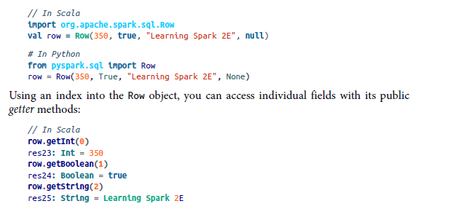

* Each element in a dataset maps to JVM object

Creating Datasets :

* As for creating Dataframe we should know schema when creating datasets (know the data types)
  + Possible to infer schema with CSV and JSON ( consume resource for large datasets )
* In scala the easiest way is to use case class // in Java JavaBean class are used

Scala: Case classes

* 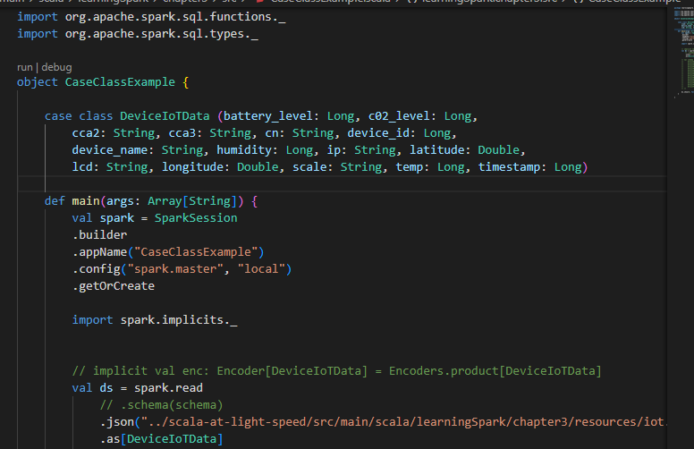

Dataset Operations

* We can also perfom transformation and action on Datasets
* Dataset Takes lambda function

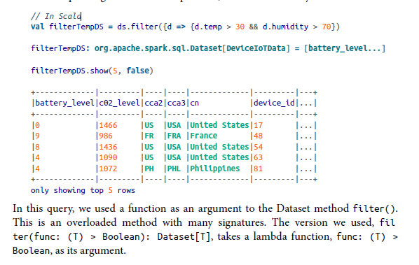

* The argument of the lambda function is a JVM object of type DeviceIoTData
  + As such can acces its fields using the dot (.)
* With DataFrame we express filter condition as SQL-like DSL operation, which are language agnostic
  + With dataset we use language-native expression as Scala or java code

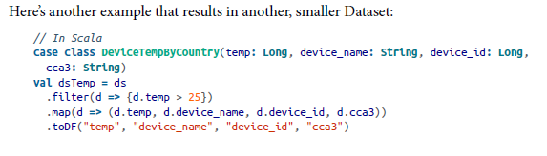

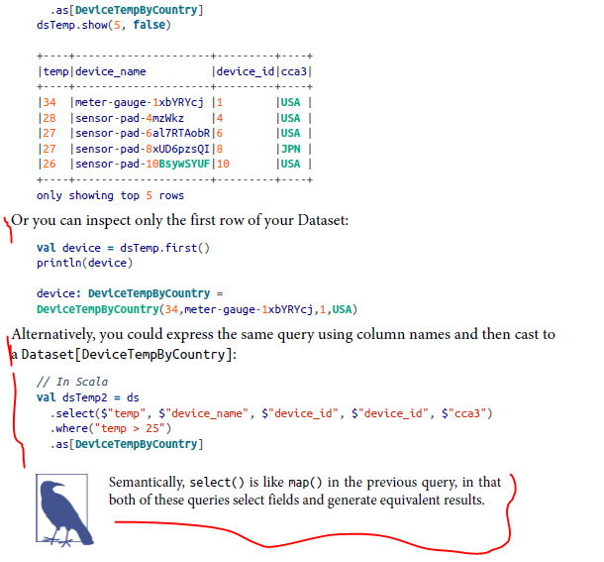

* Operations we can perform on Dataset (filer, map, groupBy, select, take etcs
  + Are similar to ones in Dataframes
  + Dataset is similar to RDD caused they provide similar interface to its aforementioned methods and compile time safety vut with a much ieasier to read and an object oriented programming interface
* When using dataset Spark SQL engine
  + Handles the creation n conversion, serialization and deserialization of the JVM objects
  + Care of java heap memory management with the help of dataset encoders

End-to-End Dataset Example

1. Detect failing devices with battery levels below a threshold.

2. Identify offending countries with high levels of CO2 emissions.

3. Compute the min and max values for temperature, battery level, CO2, and

humidity.

4. Sort and group by average temperature, CO2, humidity, and country.

DataFrames Versus Datasets

* When use DataFrame or Datasets can depend of the language we want use
* If you want tell spark what to do and not how to do it use DataFame or Datasets
* If yo want rich semantics, high level abstraction and DSL operators use Dataframes or data sets
* If you want strict compile time type safety and don’t mind createing multiple case class for a specific Dataset[T], use dataset and dataframe)
* If processing demands high level expressions (filter, maps computing average or queries
* If your processiong dictates relation transformations similar to SQL like queries, use dataframe
* If you want to take avantage of benefit from tugsten’s efficient serial
* If yiou wnant unification, code optimization , and simplifications of APIs across spark components , use dataframe
* If you are an R user, use DataFrames.
* If you are a Python user, use DataFrames and drop down to RDDs if you need more control
* If you want space and speed efficiency, use DataFrames.
* If you want errors caught during compilation rather than at runtime, choose the appropriate API as depicted in

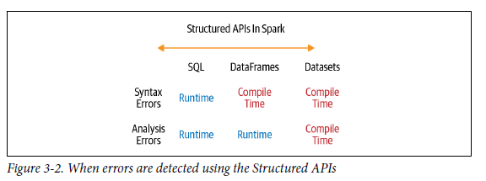

When to Use RDDs

* Using Third party package that’s writing using RDDs
* Can forgo the code optimization, efficient space utilization and performance benefits available with dataframe and datasets
* Want to precisely instrucr spark how to do a query
* Can move from DataFrame or Datasets to RDDs using (df.rdd )
* Dataframe and Dataset are built on top of RDD and decomposed to compact RDD code during whole stage code generation

Spark SQL and the Underlying Engine

* Spark SQL allow developers to issue ANSI SQL:2003(compactible queries on structured data with a schema) at programmatic level
* Spark SQL engine (Spark 3):
  + Unifies Spark components and permits abstraction to DataFrames/Datasets in Java, Scala, Python, and R, which simplifies working with structured data sets.
  + Connects to the Apache Hive metastore and tables.
  + Reads and writes structured data with a specific schema from structured file formats (JSON, CSV, Text, Avro, Parquet, ORC, etc.) and converts data into temporary tables.
  + Offers an interactive Spark SQL shell for quick data exploration.
  + Provides a bridge to (and from) external tools via standard database JDBC/ODBC connectors.
  + Generates optimized query plans and compact code for the JVM, for final execution.

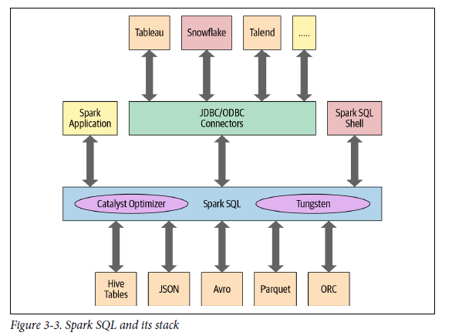

* At the core of the spark engine
  + Catalysy Optimize
  + Project Tungsten

The Catalyst Optimizer

* Catalyst optimizer takes a computational query and converts it into execution plan, it goes through
  + Analysis
  + Logical optimization
  + Physical planning
  + Code generation

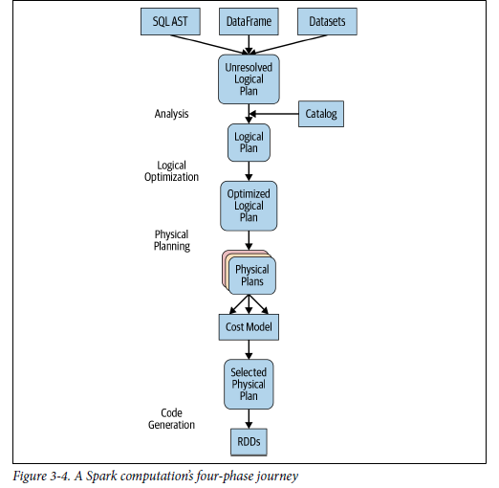

* EX

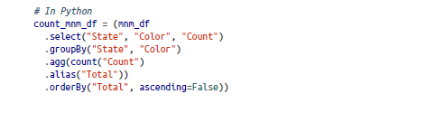

* To see plan explain df.explain python // df.queryExecution .logical or df.queryExecution.optimizedPlan (scala)

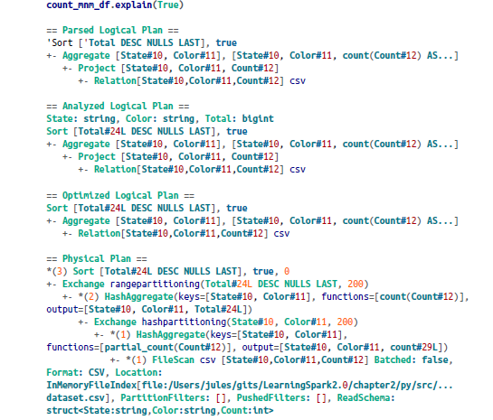

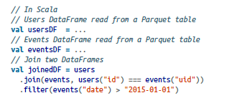

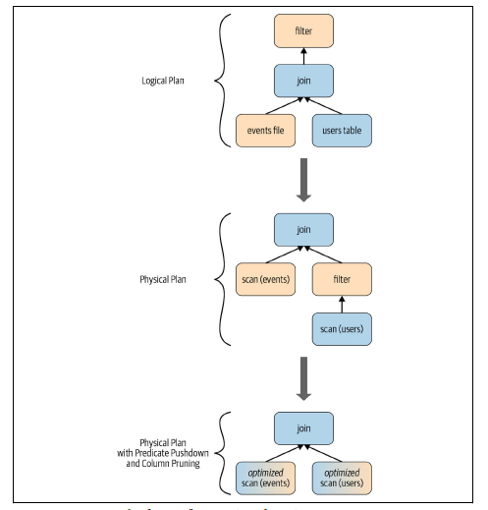

* Phase 1: Analysis
  + Spark SQL engine begins by generating an abstract syntax tree (AST) for SQL or DataFRame query
  + Here any columns or table names will be resolved by consulting internal catalog (a programmatic interface to Spark SQL that holds a list of names of columns, data types, function, tables , database)
* Phase 2: logical optimization, is composed of 2 phases
  + Applying a standard rule based optimization approach, it will first construct a set of multiple plan
  + using its cost based optimize (CBO), assign cost to each plan
  + these plan are laid out as operator trees, the may include
    - the process of constant folding, predicate pushdown, projection pruning, Boolean expression simplification
* phase 3: physical planning
  + Generate optimal physical plan for the selected logical plan using physical operators
* Phae 4: Code generation
  + Generating efficient java bytecode to run on each machine
  + Can be use **state of the art compiler technology** for code generation due to the fact that spark can operate data in memory to speed execution (acts as a compiler )
  + Project tungsten which facilitates whole stage code generation plays a role here
    - Whole stage code generation : physical query optimization phase that collapses the whole query into a single function, getting rid of virtual function calls and employing CPU register for intermediate data
    - In spark 2.0 the second generation Tungsten engine use this approach to generate compact RDD code for final uexcutin (CPU efficiency and performance)

I

We have talked at a conceptual level about the workings of the

Spark SQL engine, with its two principal components: the Catalyst

optimizer and Project Tungsten. The internal technical workings

are beyond the scope of this book; however, for the curious, we

encourage you to check out the references in the text for in-depth

technical discussions.

CHAPTER 4

Spark SQL and DataFrames:

Introduction to Built-in Data Sources

Using Spark SQL in Spark Applications

* The sparksession introduced in spark 2.0 provides a unified entry point for programming spark with the structured APIs
* Sparksession can be used to access spark functionality
* To trait any sql query we use sql() method on the SparkSession instance, spark   
  such as spark.sql("SELECT * FROM myTableName")

Basic Query Examples